Робота
Учасника І етапу
Всеукраїнської олімпіади
з англійської мови
спеціалізованої школи № 304
Уч_____ _____класу
П.І.Б.___________________________________________________
Вчитель_________________________________________________

- Match (З’єднай)
1 drink
d
2 eat

3 play

4 read

5 go

6 fly

a the menu
b to a museum
c a model plane
d a cup of coffee
e the violin
f pancakes

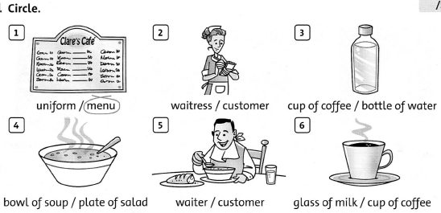
- Circle (Обведи)

- Write ll or rr (Напиши ll або rr)

- Ca___ot
- Sme__
- Mi__or
- Be__
- Che__y
- She__

- Write sentences about you using the present simple, present continuous and past simple tenses. Use these words:
sometimes right now yesterday usually last week
(Напиши речення про себе використовуючи present simple, present continuous and past simple. Використай ці слова:
sometimes right now yesterday usually last week)

1 I went to the cinema yesterday.
2______________________________________________
3______________________________________________
4______________________________________________
5______________________________________________
6______________________________________________

(go to the cinema)
(visit grandma)
(eat pizza)
(get up)
(study English)
(watch TV)

- Complete the sentences :have to had to has to (Доповніть речення словами: have to had to has to)
1 We had to hurry yesterday.
2 Melanie ______ turn left now.
3 Dani ______ go back five minutes ago.
4 They ______ read a map when they are Lost.
S Jack ______ stop at the traffic lights now.
6 Now you ______ go straight on.
7 I ______ turn right half an hour ago.
- Read the dialogue. Write T (true) or F (false). (Прочитай діалог і напиши T, якщо правда та F, якщо неправда)
Joe I like these white trainers. They're better than my blue ones.
Lee Yes, look! They're softer and more comfortable.
Joe But they're the most expensive ones in the shop. I'd like some cheaper ones.
Lee What about these green ones? These are the least expensive in the shop.
Joe Yes, they're nice. But these orange ones are the best. Look, they're comfortable
but they're cheaper than the white ones. I'm going to buy these.

1 The white trainers are better than the blue trainers.
2 The blue trainers are more comfortable than the white trainers.
3 The white trainers are softer than the blue ones.
4 The white trainers are the least expensive in the shop.
5 The green trainers are the best.
6 The orange trainers are cheaper than the white trainers.
T
__
__
__
__
__

